Create Table Customer (

CustomerId Int Primary Key,

CustomerName Varchar(100),

ContactNo Varchar(20),

Address Varchar(100),

City Varchar(50),

Postalcode Varchar(10),

Country Varchar(50));

Desc Customer;

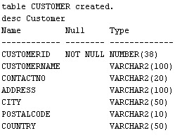

Insert Into Customer Values (1, 'Alice', '1234567890', '123 Elm St', 'New York', '10001', 'USA');

Insert Into Customer Values(2, 'Bob', '9876543210', '456 Oak St', 'Los Angeles', '90001', 'USA');

Insert Into Customer Values(3, 'Charlie', '5555555555', '789 Pine St', 'London', 'E1 6AN', 'UK');

Insert Into Customer Values(4, 'David', '4444444444', '321 Maple St', 'New York', '10002', 'USA');

Insert Into Customer Values(5, 'Eva', '3333333333', '654 Cedar St', 'Paris', '75000', 'France');

Select * From Customer;

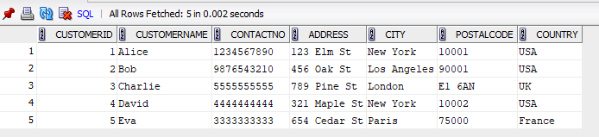

Create Table Employees (

EmployeeId Int Primary Key,

LastName Varchar(50),

FirstName Varchar(50),

BirthDate Int);

Desc Employees;

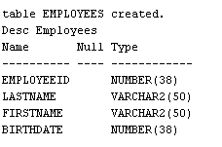

Insert Into Employees Values (1,'Roberts','Julia',To_Date('1970-05-15','YYYY-MM-DD'), Null);

Insert Into Employees Values (2, 'Queen', 'Elizabeth', To_Date('1980-08-30','YYYY-MM-DD'), Null);

Insert Into Employees Values (3, 'Prince', 'Charles', To_Date('1975-11-20','YYYY-MM-DD'), Null);

Insert Into Employees Values (4, 'Duke', 'William', To_Date('1990-01-10','YYYY-MM-DD'), Null);

Insert Into Employees Values (5, 'Duchess', 'Kate', To_Date('1985-03-25','YYYY-MM-DD'), Null);

Select * From Employees;

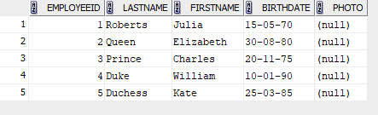

Create Table Orders (

OrderId Int Primary Key,

CustomerId Int,

EmployeeId Int,

OrderDate Int,

ShipperId Int,

Foreign Key (CustomerId) References Customer(CustomerId)

Foreign Key (EmployeeId) References Employee(EmployeeId));

Desc Orders;

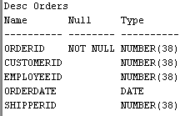

Insert Into Orders Values (1, 1, 2, To_Date('2025-08-01', 'YYYY-MM-DD'),101);

Insert Into Orders Values (2, 3, 1, To_Date('2025-08-02', 'YYYY-MM-DD'),102);

Insert Into Orders Values (3, 5, 3, To_Date('2025-08-03', 'YYYY-MM-DD'),103);

Insert Into Orders Values (4, 2, 4, To_Date('2025-08-04', 'YYYY-MM-DD'),101);

Insert Into Orders Values (5, 4, 5, To_Date('2025-08-05', 'YYYY-MM-DD'),102);

Select * From Orders;

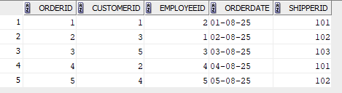

**QUESTIONS**

1.Select * From Customer Order By Customername Asc;

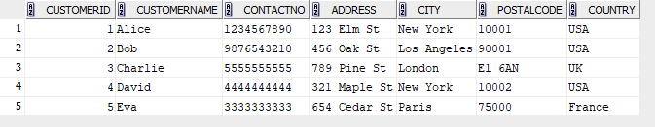

2.Select * From Orders Order By Orderdate Asc;

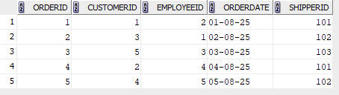

3.Select * From Employees Where Extract(Year From Birthdate)>1980

Order By BirthDate desc;

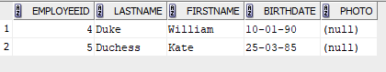

4.Select * From Orders Where Customerid in(Select Customerid from Customer where Country='USA') Order By OrderDate desc;

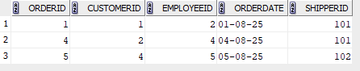

5.Select c.Customerid, c.Customername, (

SELECT COUNT(*)

FROM orders o

WHERE o.customerid = c.Customerid

) AS total_orders From Customer C Order By C.Customerid;

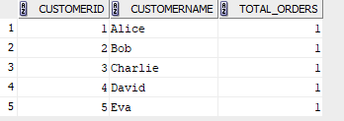

6. SELECT City, COUNT(*) AS Total_Customers

FROM Customer

GROUP BY City

Order By Total_Customers Desc;

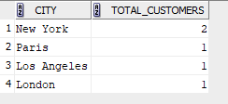

7. SELECT c.Customerid,c.Customername, COUNT(o.Orderid) AS Total_Orders

From Customer C

JOIN Orders o ON c.CustomerID = o.CustomerID

Group By C.Customerid, C.Customername

Having Count(O.Orderid) > 2

Order By Total_Orders Desc;



8. SELECT City, COUNT(*) AS Total_Customers

FROM Customer

GROUP BY City

Having Count(*) > 3

Order By Total_Customers Desc;

